# Ex. No:2 Roll No: 230701396

**Date:06/08/2024 Name: M.Praveenraj**

DATA MANIPULATIONS

**1. create table employees (employee_id number(6),First_Name varchar(20),Last_Name varchar(25),Email varchar(25),Phone_number varchar(20),hire_date date,Job_id varchar(10),Salary number(8,2),Commission_pct number(2,2),Manager_id number(6),Department_id number(4));**

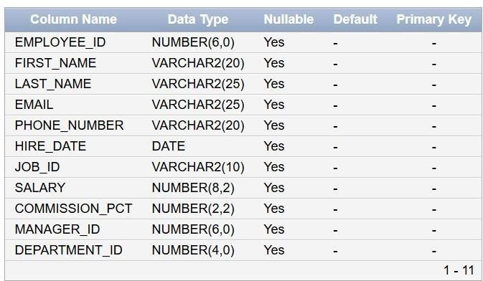

**Insert into employees**

**values(3,'Ralph','Patel','rpatel@gmail.com',9768403822,'11-12-2000',13,5000,.25,101,40);**

**Insert into employees**

**values(4,'George','Austin','geaustin@gmail.com',9573268191,'09-10-2018',14,6000,.3,103,60);**

**Insert into employees values (1,'Ben','Chad','bchad@gmail.com',9493836325,'24-07-2022',11,4500,.15,100,70);**

**Insert into employees values (2,'Bety','Dancs','bdancs@gmail.com',9763467298,'19-05-2021',12,4800,.17,100,56);**

**Insert into employees values (5,'Audrey','Austin','audaustin@gmail.com',9684357377,'06-05-2017',15,7000,.35,104,80);**

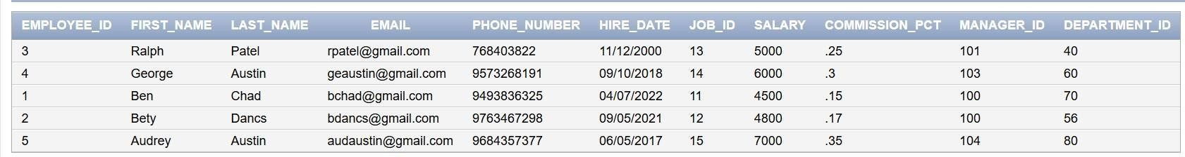

**select employee_id,first_name,last_name,salary from employees;**

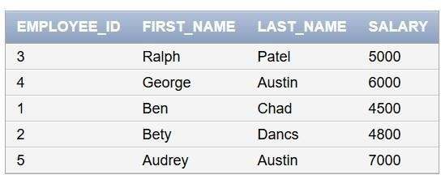

**select *from employees where manager_id=100;**



**select first_name,last_name from employees where salary>=4800;**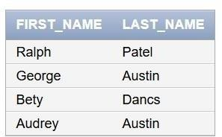

**select *from employees where last_name ='Austin';**



**select first_name ,last_name from employees where department_id=60 or department_id=70 or department_id=80;**

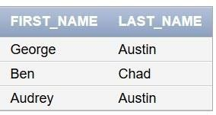

**select distinct manager_id from employees;**

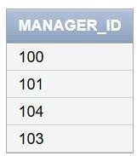

# 2B

**create table emp1(empno number(4),empname varchar(25),job varchar(25),basic number(10),da number(10),hra number(10),pf number(10),grosspay number(10),netpay number(10));**

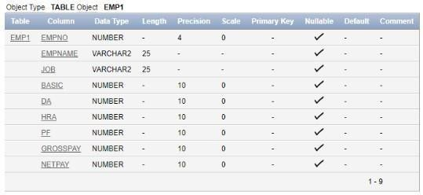

**insert into emp1 values(1,&#39;betty&#39;,&#39;manager&#39;,7000,2100,2800,1000,10,20); insert into emp1 values(2,&#39;annnie&#39;,&#39;secretary&#39;,5000,1500,2000,1500,20,30); insert into emp1 values(3,&#39;ralph&#39;,&#39;technician&#39;,8000,2400,3200,2000,30,40); insert into emp1 values(4,&#39;linda&#39;,&#39;assistant&#39;,4000,1200,1600,1200,40,50); insert into emp1 values(5,&#39;becky&#39;,&#39;manager&#39;,9000,2700,3600,2500,50,60);**

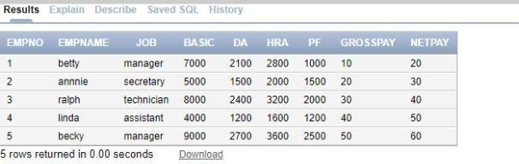

**update emp1 set grosspay=basic+da+hra+ pf; set netpay=basic-pf;**

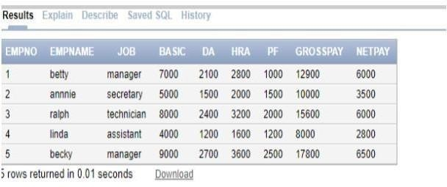

**select * from emp1 where basic=(select min(basic) from emp1);**

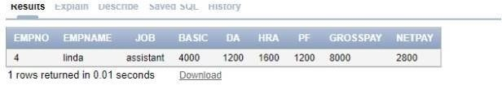

**select * from emp1 where netpay=(select min(netpay)from emp1);**

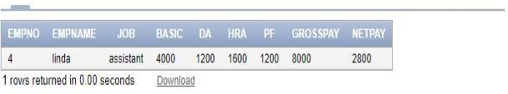

**2C**

**create table emp3(id number(7) primary key not null,last_name varchar2(25) not null,first_name varchar2(25),dept_id number(7));**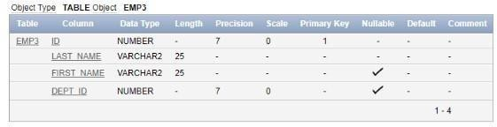

**alter table emp3 modify last_name varchar2(50);**

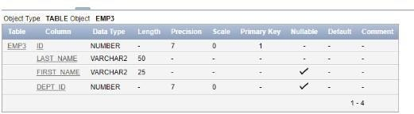

**create table employees2(employee_id number(4),first_name varchar(25),last_name varchar(20),salary number(10),dept_id varchar(5));**

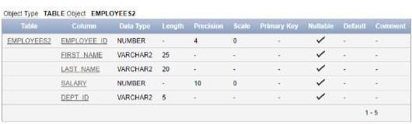

**drop table emp3;**

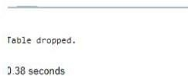

**alter table employees2 rename to emp3;**

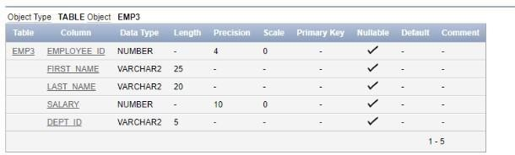

**alter table emp3 drop column first_name;**

